JUNIT OUTPUTS:
Junit exercise 1:
No output, only changes to pom.xml

Junit Exercise 3:
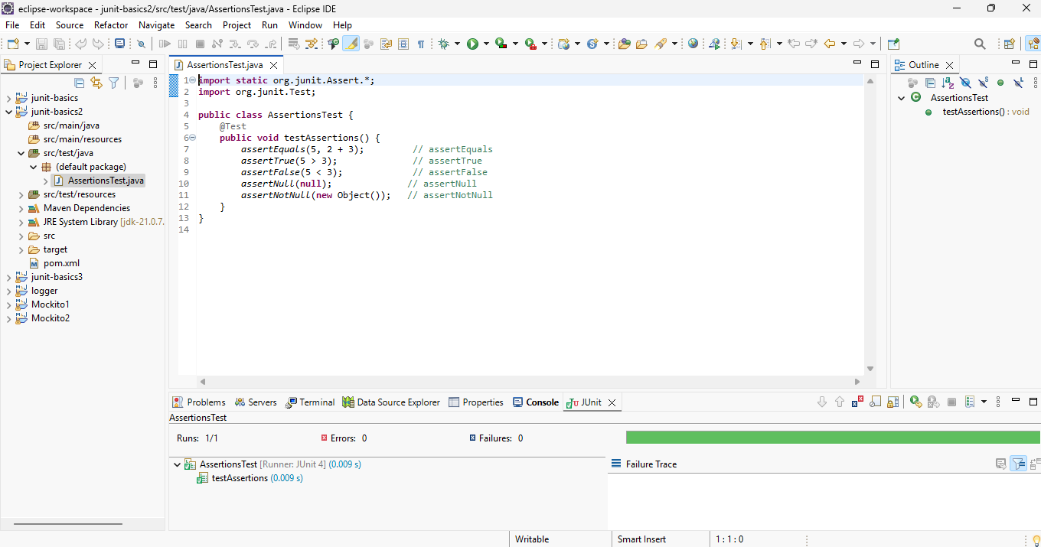

Junit Exercise 4:
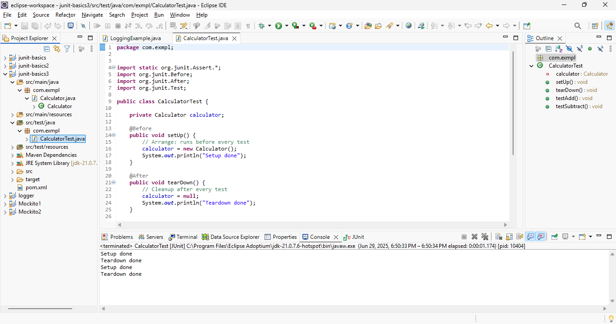
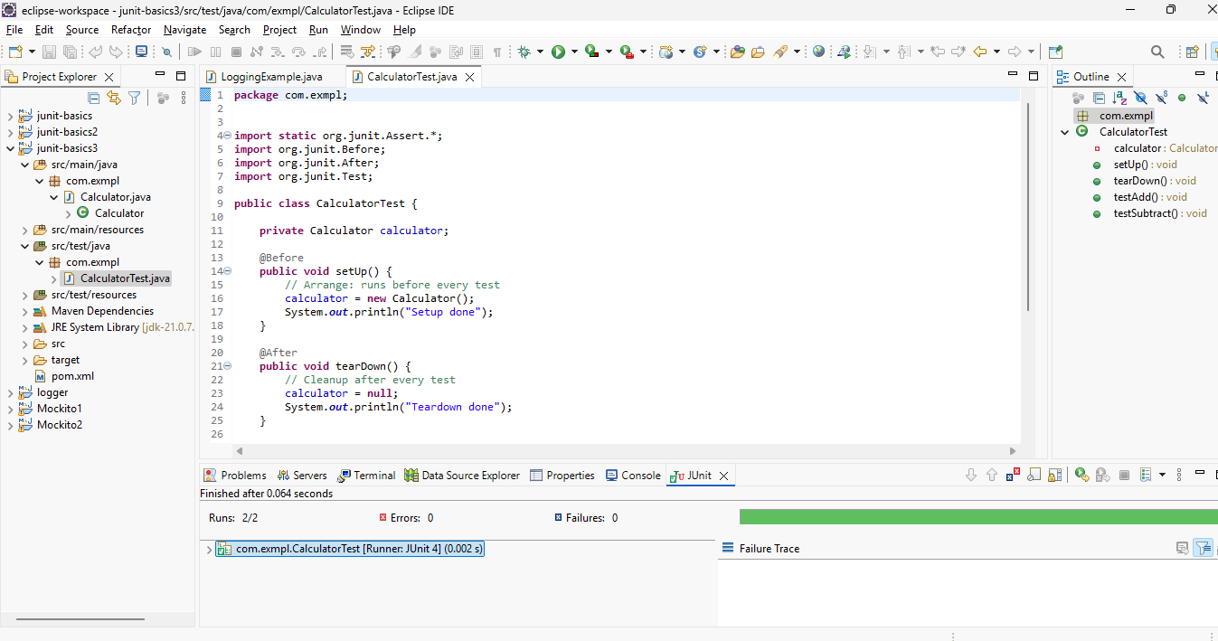

Mockito Exercise 1 :
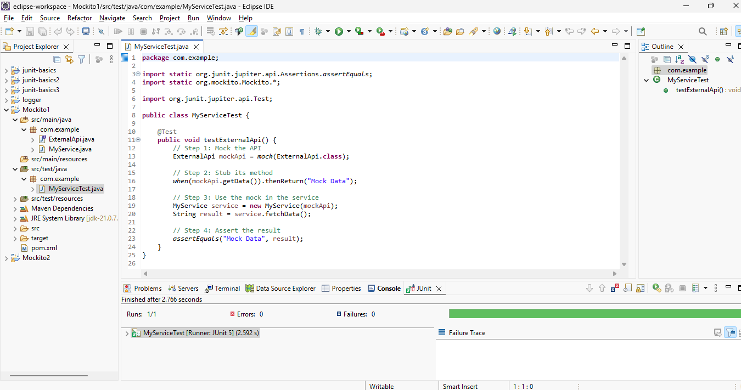

Mockito Exercise 2:
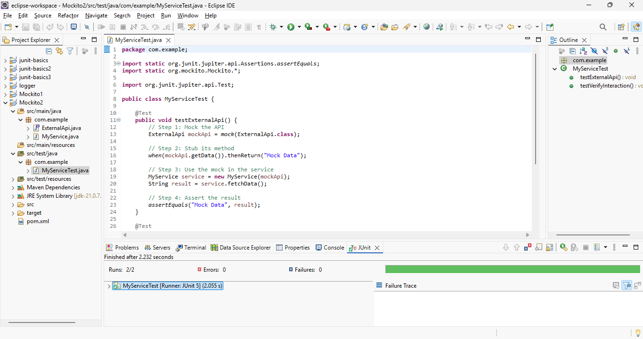

Logger Exercise 1:
